1. **Low-Cost Mobile Weather Station for disaster preparedness and management in Nepal**

**Or**

1. **Low-Cost Weather Station for climate change and weather studies in Nepal (*preferred*)***

(Maybe we have to rethink on this first sentence if the second topic is selected.) (Nepal is highly prone to weather and water-related disasters such as flooding, drought, thunderstorms, and landslides, the impacts of which often transcend national boundaries.) Climate change has raised the specter that extreme weather events' frequency and intensity could increase in the coming decades. Recognizing the nature of hydrological and meteorological (hydromet) hazards in Nepal, improved weather and flood forecasting system, community-based early warning systems, and delivery of hydromet services to users and communities are very important. To achieve this goal, strengthening the capacity of local institutions to respond to weather and water-related hazards and climate risks at the national and regional levels is a must.

In this project, we have made a mobile weather station that can be carried from one place to another to read the data of environmental parameters. We have used temperature, humidity, wind speed/direction, rainfall, and barometric pressure sensors to read the weather conditions and applied the Kalman filter method to obtain the data out of the noise for the best estimate. This system is microcontroller based portable, low cost, made primarily from locally available materials, and can be used under different climatic conditions. The completion of this project has yielded environmental readings with high accuracy and very negligible error value. This result helps strengthen the capacity of national/subbasin institutions to manage hydrological and meteorological hazards and deliver accurate weather-based information.

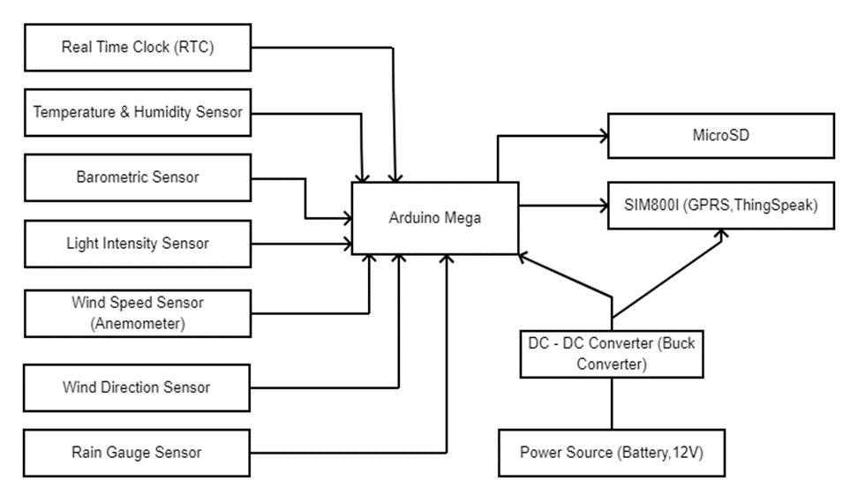

If any block diagram of this type is required, please do inbox.